10th FLOOR POOL DECK & BAR AREA
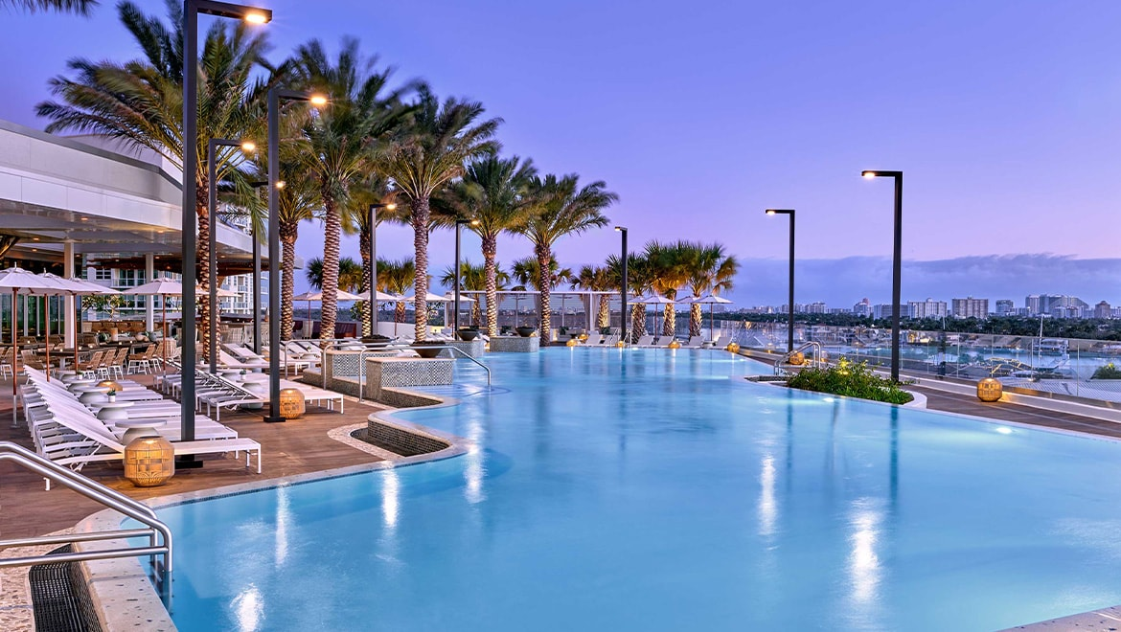
The Omni’s 10th floor pool that looks out over the Stranahan River, 17th St. E. Clay Shaw Jr. Bridge, and the Broward Convention Center.
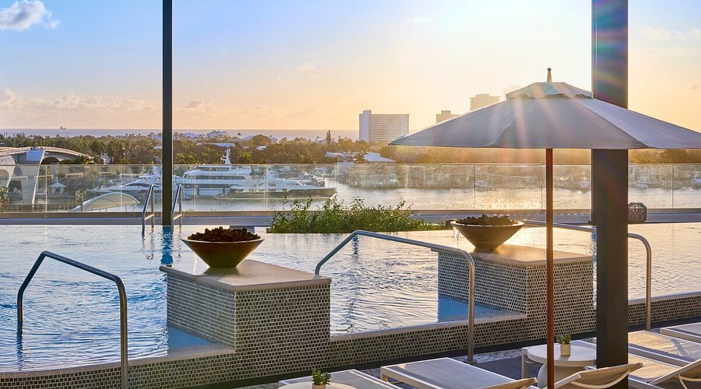 The infinity pool edge merges seamlessly with the glass safety barrier, drawing the eye toward the waterfront view. It is complemented with rows of crisp, low-profile white loungers that orient toward the sun and views.
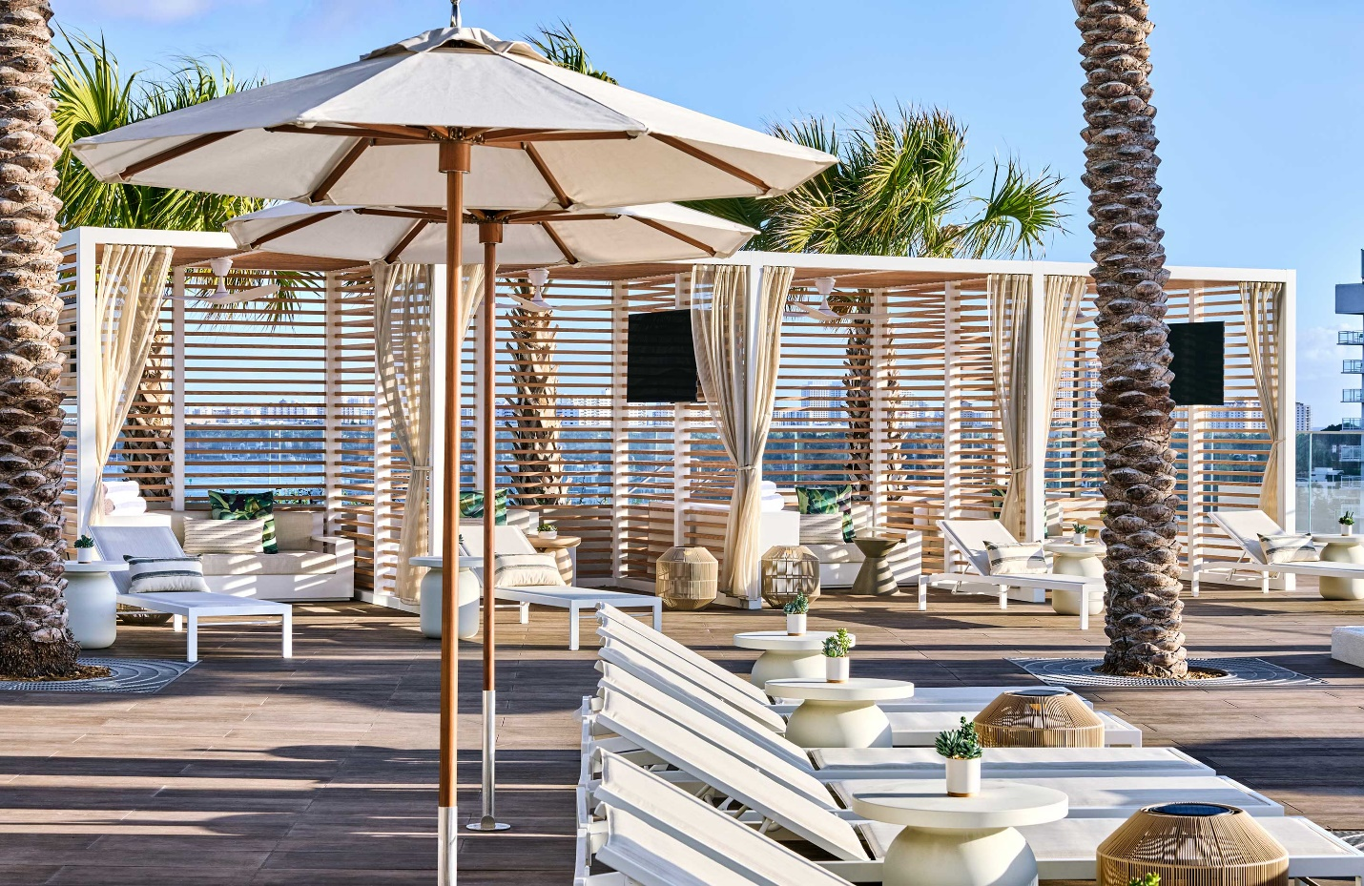 The pool deck blends structured coastal geometry with breezy luxury to create a sophisticated, sun-drenched sanctuary. Modular slatted timber cabanas with horizontal louvers offer a balance of privacy and filtered sunlight, while breezy, off-white sheer curtains, tied at the columns, soften the linear architecture. Spherical, natural rattan lantern floor lamps provide organic texture and ambient evening lighting. Large, octagonal canvas umbrellas with warm wood poles offer adjustable, localized shade.
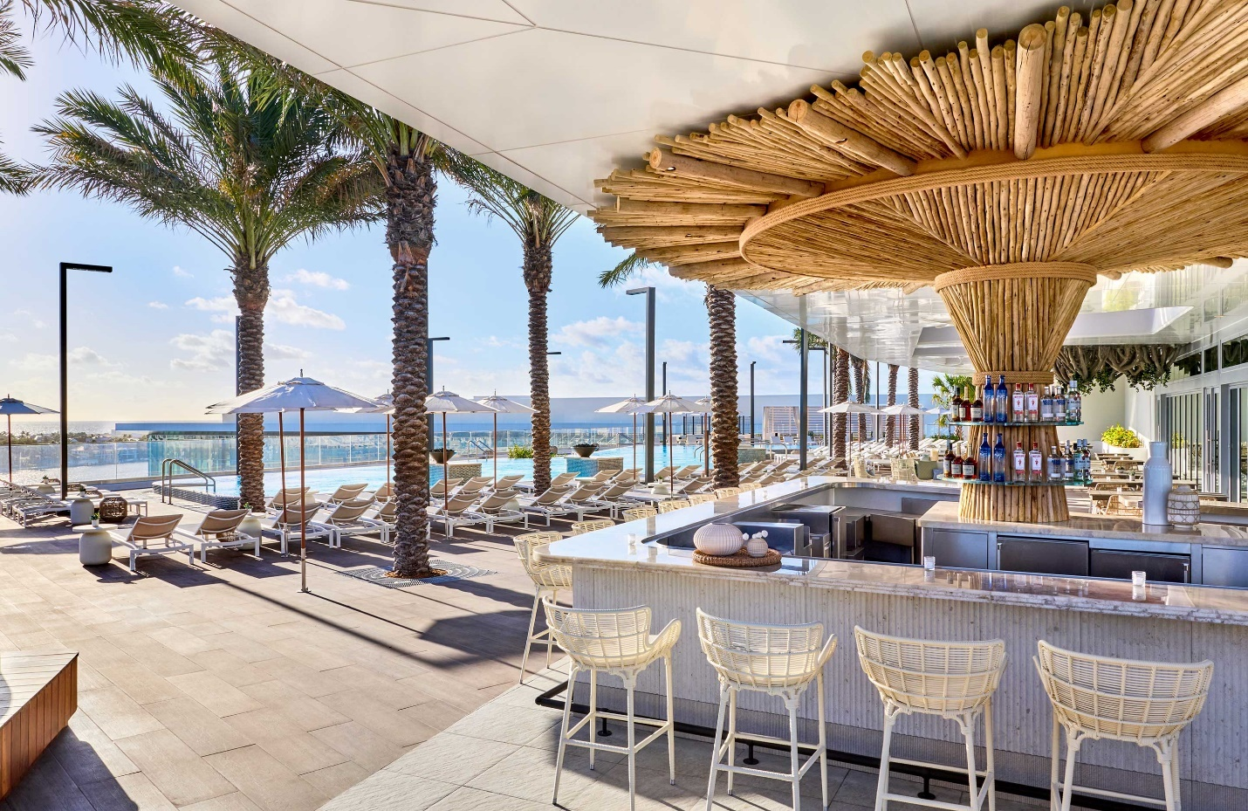
The bar blends artisanal tropical craft elements with contemporary coastal minimalism to create an inviting, resort-style hospitality environment. A central pillar wrapped in bundled bamboo stalks draws the eye upward to a dramatic, radial wooden canopy. A coiled natural rope accents anchor the bamboo structure, adding tactile, nautical texture. Low-back, white-washed woven resin counter stools offer comfortable seating with a breezy, open-air aesthetic. Rows of matching white chaise lounges and minimalist market umbrellas line the pool deck to maximize sun exposure. Lines of palms offer a linear grid, adding vertical scale and tropical framing.
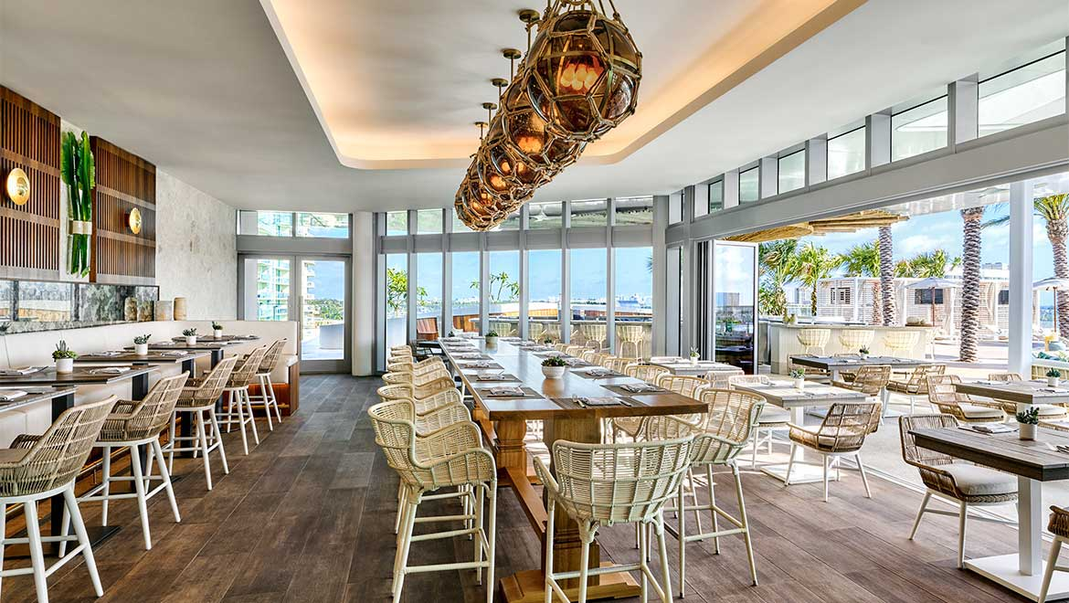
Opening up to the bar and poolside area is the Tide Coastal Kitchen. Offering a blended indoor/outdoor dining experience, the room’s neutral tones are accented by wall-mounted hand-blown glass palm frond sculptures created by local artist Rob Stern. Spherical pendant lights wrapped in decorative netting complement the light wood, woven rattan chairs and dark wood-plank flooring.

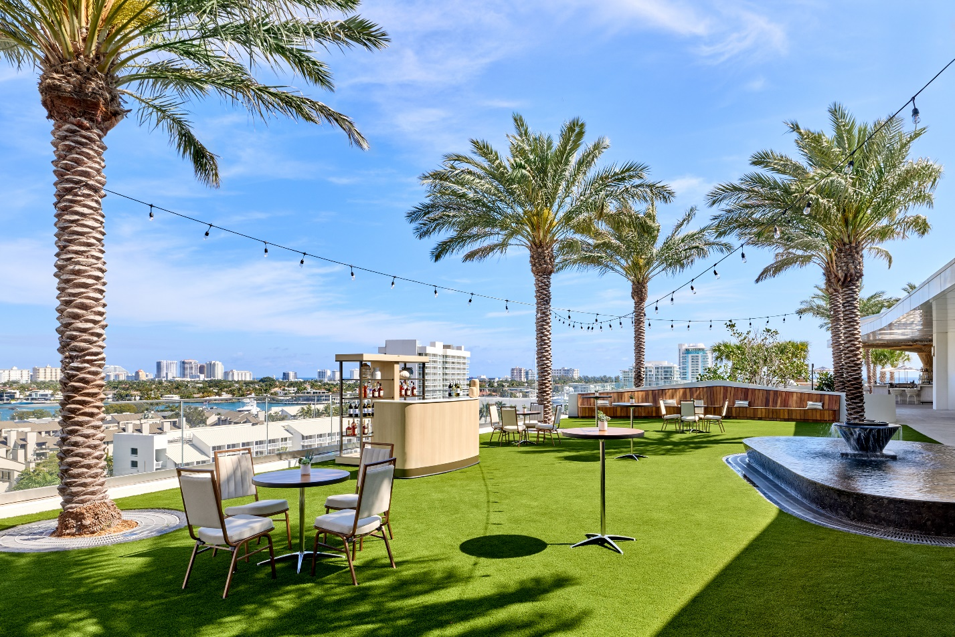 The event lawn is designed for both relaxation and gatherings, and offers both a water feature and a fire pit. The space is defined by strings of festive lights and mature palm trees that frame panoramic views of the Fort Lauderdale skyline and the Intracoastal Waterway.

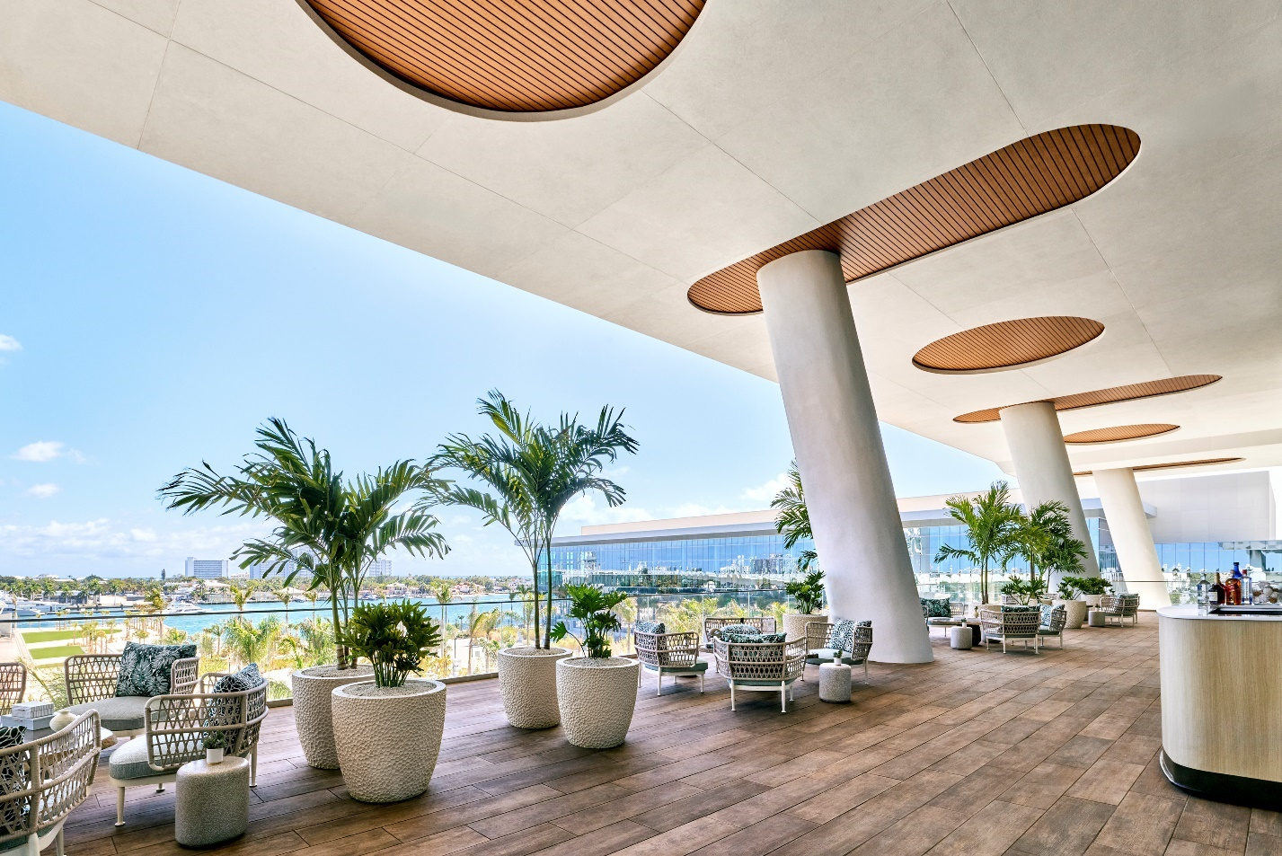
This upscale outdoor terrace is one of several that overlook the Stranahan River, 17th St. E. Clay Shaw Jr. Bridge, and the Broward Convention Center. The design blends modern architectural elements with organic textures to create a sophisticated, coastal hospitality space. Angled structural concrete pillars tilt outward to maximize panoramic views. Elongated oval openings break up the concrete canopy overhead. Ribbed, slatted wood paneling lines the ceiling cutouts to contrast the stark concrete.
Low-profile, modern armchairs and sofas feature intricate woven rope backrests and pale upholstery. The furniture is organized into intimate conversation zones to facilitate small group gatherings. Small, textured cylindrical stone plinths serve as low-maintenance cocktail tables. Biophilic accent décor is defined through textured oversized planters. The large, white, dimpled ceramic pots add tactile interest to the deck, while the tall, slender palms bring vibrant greenery and a touch of natural shade into the seating areas.

